Lakshmi Narain College of Technology & Science, Bhopal

Department of Electronics and Communication Engineering

Name: Madhuri Darkar Enrolment no.:0157EC181048 Class: EC V D

Date: 27/08/20 Page no.: 15

**PRACTICAL-5**

Aim: To perform operations on matrix.

Software required: Scilab version 6.0.2

Define a matrix as P= [11,13,15;5,4,7;19,7,8] and perform on it following operations:

1. Find the determinant of the matrix
2. Find the inverse if the matrix
3. Calculate the eigen value of the matrix

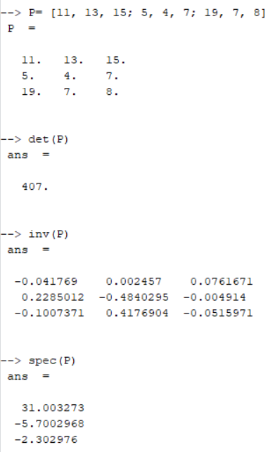

Teacher’s signature